ARE YOU AND YOUR FAMILY LOOKING FOR FUN AGE-APPROPRIATE ACTIVITIES TO DO WITH YOUR CHILD AT HOME



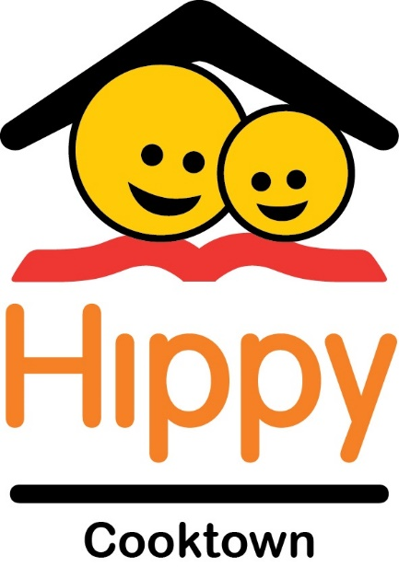

**ABN:** 45180964190

**ICN:** 148

**H**ome **I**nteraction **P**arenting **P**rogram for **Y**oungsters

***The Home Interaction Program for Parents and Youngsters is funded by the Australian Government through the Department of Social Services. The Brotherhood of St Laurence holds the licence to operate HIPPY in Australia.***

HIPPY is a free 2-year, home based early learning program designed to support families who want to prepare their child for PREP 2022.

**WHO IS ELIGIBLE?**

All children in their Pre-Prep year

(starting Prep in 2022)

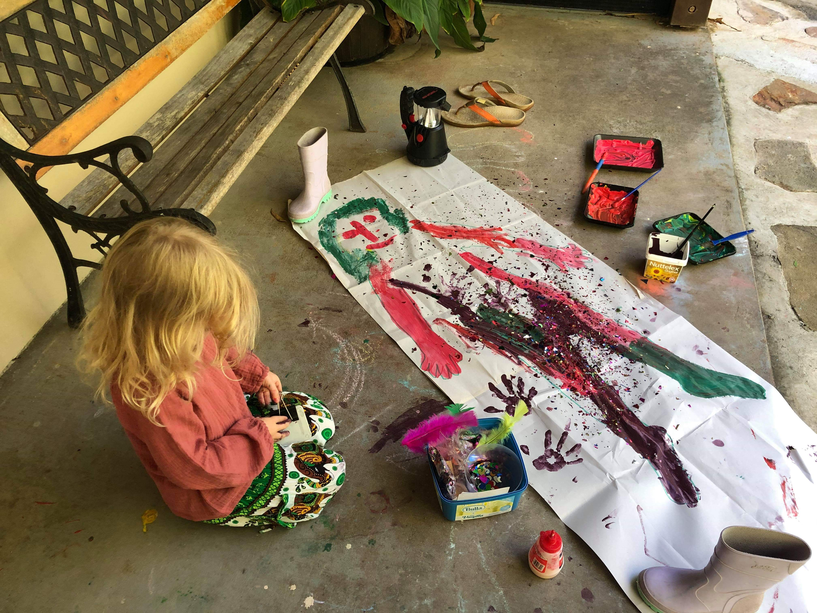

Families learn how to make early learning fun and engaging.

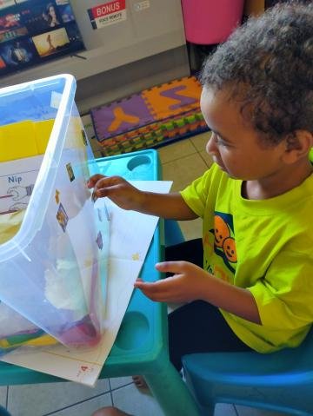

HIPPY provides all storybooks, activity books and resources for families to do the program at home.

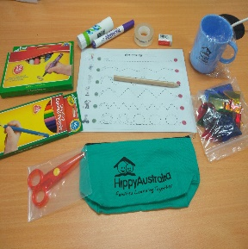

**ALL FAMILIES RECEIVE A STARTER PACK FREE**

YOU RECEIVE A TOTAL OF 17 STORY BOOKS FREE

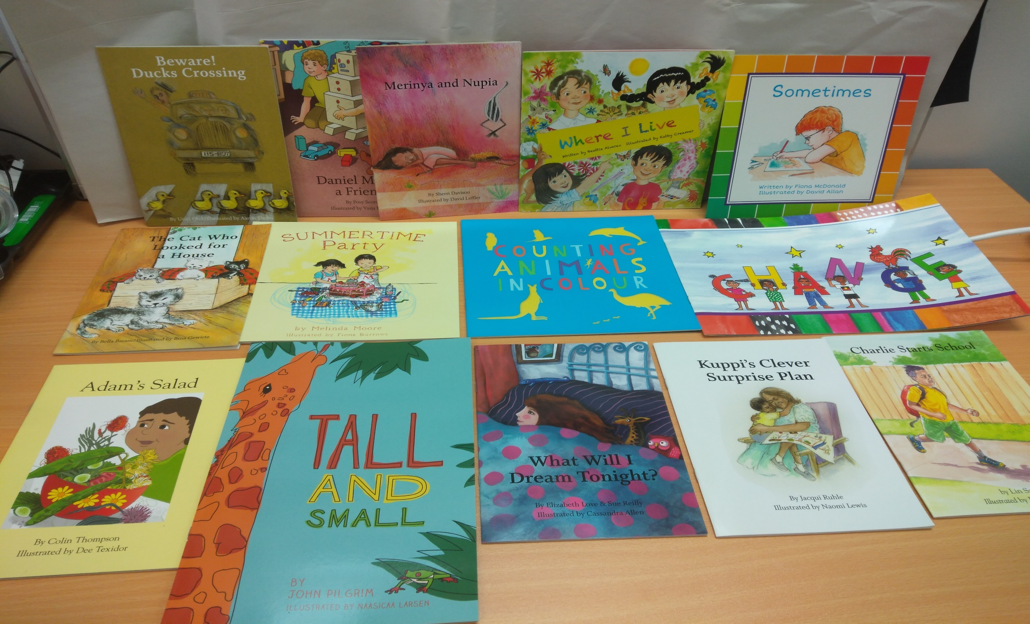

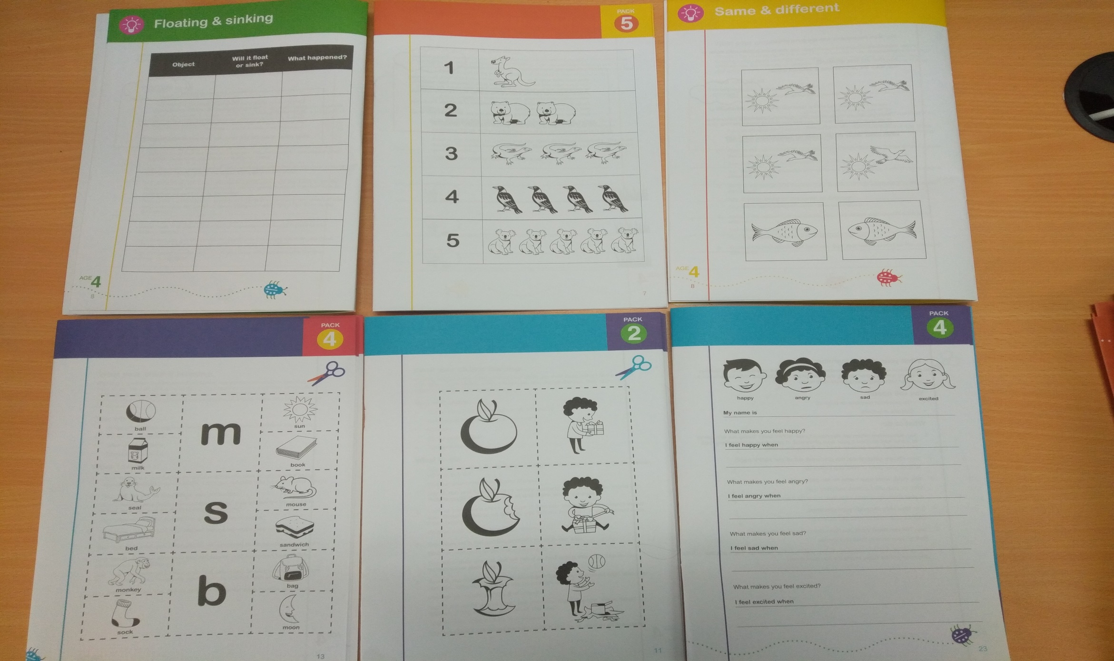

45 ACTIVITY BOOKS OVER 2 YEARS WHICH FOCUS ON THINKING AND EXPLORING, COMMUNICATION, CREATIVITY, SOCIAL & EMOTIONAL AND FAMILY & COMMUNITY

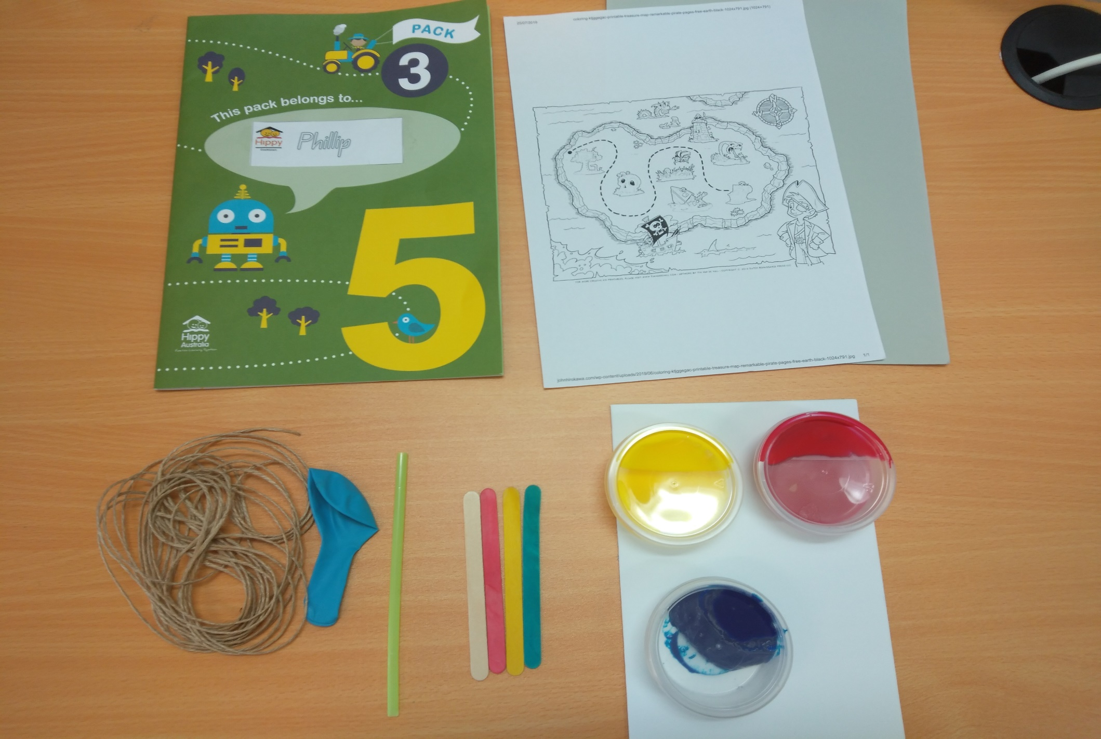

EACH PACK COMES WITH THE RESOURCES NEEDED FOR THE ACTIVITIES

**ENROL NOW**

**Limited intake of families**

**Contact us on 0498558726**

